Consumer Decision Making Process
Members:
School name
Instructor:
27/09/2018

PART A: Consumer Decision Making Process
Market segment 1A and 1B
- Decision to travel
Market segment 1A
In this group, the idea is to influence consumer decision-making process for a vacation destination decision. This team of consumers have the best characteristics that one can use to give the best ideas concerning a travel destination. There are many reasons why the team is easy to influence. For example;
- The consumer groups is young
- The group is made up of couples who don’t have children
- They work as part timers thus they have a lot of time to travel
- They are not marriage hence no family commitments
- They are university graduates who in most cases are party animals
- They love celebrity life e.g. buying expensive items,
- They believe in higher priced products, which are of high quality.
Market segment 1B
This group of consumers have almost the same characteristics as group 1A. For example;
- They are young and energetics
- Males
- Well educated individual
- They also work in part-time
- Single and no children
- They are opinionated
- They don’t love popular brands
In group 1A, the choices and consumption is made for the purposes of maximum satisfaction and destination experiences. There is a high level of expenditure in the consumer bracket. This means that consumers have a strong influence towards exclusive destinations, products. For example, they value expensive products and they can spend any amount just to buy what they want. The consumer bracket therefore can be easily lured to buy expensive brands, which they deem of high quality.
Tourism has become a blooming industry and the young people, e.g. young couples are the highest number/percentage of the consumers. The young couples love movements and trends thus they make their decisions in line with travelling with the best brands, spending mush in their holidays. Their preference is to have the best no matter how much they are going to pay for the services. As a couple, they must make a conjoint analysis while evaluating the best product or service which is best for them. They are learned people therefore; they must collect data about their travel destinations before they settle for the best option.
In group 1B consumer decision making process, the group is more or less making similar decisions. However, the group consists of men. This means that they might not be influenced to make decisions that are fancy. They only settle for the “simple and best.” They only go for classic decision-making. The consumer group goes through a transit of stages before they make their final decision. The stages are;
- Need recognition
- Search for information
- Evaluate all the available options
- Choose the best product or service
- Post-purchase evaluation
Before settling for an option, this group of consumers draw information and decide which is the best product or service. This means that what others think does not influence their decision-making in the best travel destination. Expensive items or services cannot be their decision not unless is draws their satisfaction.
- Decision to buy a car
Market segment 1A and 2A
As we have seen before, market segment 1A is made of young and energetic people who are willing to go for any product or service on the market. They can pay much and are influenced by trend fashions such as pay for the most expensive air ticket to get their satisfaction. The market segment 2A is made of the following characteristics;
- No children
- Young couples, single
- They love to spend much on high quality
- They don’t buy out of influence
- Not opinionated
In the consumer decision making process to buy a car, these two groups of consumers would approach the process differently. For example, in group 1A, they can be easily influenced to buy a car, which are in fashion, and expensive, the group loves expensive items of high quality. It is most likely that group 1A have a taste in high-end vehicles, sporty and fashionable.
Market segment 2A also love to spend much on high quality. This means that their decision making process could be influenced by the desire to have a quality and expensive car. The group don’t rely on what people tell them about cars and will only buy from what they think is the best. When the car brand is popular, it might not be their choice.
PART B: Motivation
- Decision to donate to the local art gallery (Multiattribute attitude model)
1D and 2D
1D
The characteristics considered in understanding their decision making process are;
- Group 1D is made up of single parents with two children.
- They are working class people which means they have money
- They are middle aged
- They are undergrads
The decision making process of this group to donate to a local art gallery is influenced by their earning capability. They are able to afford some amount to donate. There like to focus on solving problems in the society through making of donations. Through donations, they believe that they are helping themselves together with their future generations. The group also wants to satisfy the feeling of helping others and contributing towards the development of the community.
2D
The 2D group of consumers are most likely going to contribute to the local art gallery. They have children who are beneficiaries of the gallery and would like their children to access a well-equipped facility in future. They are employed and can be influenced by other people to donate which they will definitely do.
Buying life insurance (Multiattribute attitude model)
1C and 2C
Market segment 1C and 2C
Group 1C is made up of the following characteristics that will influence their decision to buy a life insurance
- Middle age (30-35)
- Just friends and married with 2 children
- They are undergraduates
- Both are employed
This group of customers have a taste in high quality and high priced commodities; there is a likelihood that they will buy the best quality despite the price being high. Popular brands also ignite them. They are married and have children, which means that they will go for insurance product that covers the entire family. Furthermore, they have the money since they are both working. This group of customers have little knowledge of the best life insurance policy in the market and will depend on others for advice.
Group 2C has the following characteristics that will influence their decision making process;
- These are also middle aged group of consumers
- They are married with two children
- They don’t spend much for better quality products or services
- They don’t buy what experts tell them to buy
Looking at the above characteristics, it is most likely that the decision to buy a car will be influenced by the desire to have a life insurance that covers the entire family. They can also buy expensive life insurance policies for the family. The group love expensive products but can also be motivated to go for cheap ways of solving issues as well (Blythe, 2017).
PART C: Attitudes
- Stop using credit for one week in protest against financial institutions (Theory of trying to consume)
Market segment 1A and 1B
This group of consumers are young individual as reviewed in the previous segments above. They seem to be making a certain attempt to consume or purchase a certain product or service. There are many reasons that this group of customers might not be willing to consume certain financial services from a particular financial institution. The reason could be overcharging, standing orders, delay in remitting payments etc. They are trying to seek for better services (Mooij, 2014).
- Switch from traditional taxis to UBER
Market segment 1F and 2F
Group 1F and 2F is composed of female consumers who are aged, married, and employed. They are undergrads therefore; chances are that they are not trendy. No children so it is a simple family. They like quality products and services and can spend to get them. That is why they would switch very quickly from using the traditional taxis to UBER.
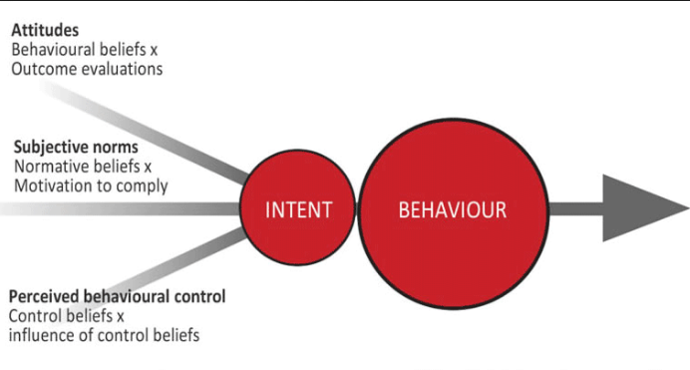
From the chart above, they believe that UBER has better services that the traditional taxis. They are motivated to get the best. Their motivation or behavioral beliefs are guided towards getting the getting the most desired outcome (Wright, 2016).

References
Bagozzi, R. P., Gurhan-Canli, Z., & Priester, J. R. (2012). The social psychology of consumer behaviour. Buckingham [England: Open University Press.
Blythe, J. (2017). The essence of consumer behaviour. London: Prentice-Hall.
Mooij, M. K. (2014). Consumer behavior and culture: Consequences for global marketing and advertising. Thousand Oaks, Calif: Sage Publications.
Wright, R. (2016). Consumer behaviour. London: Thompson Learning.

